Press Release
Compressed Air Work GmbH
www.compressed-air-work.net
February 2015

Pioneering in Safety & Productivity work on the Tunneling Construction:
Compressed Air Work GmbH has develop the first mobile automatization system for decompression chambers for personnel CAIS – Compress Air Intervention System. Fundamentally consist of digital touchscreen recording technology to register all relevant information of the workers in compressed air intervention on tunnel construction sites that employ tunnel boring machines ( TBM ) and for all other caisson work.

It is a revolutionary improvement on the work site firstly because, it contains all the components needed for the mobile automation system, and secondly, it houses oxygen reading devices, digital displays that provide all the requisite data and figures for the man “lock attendant” and all controls of the mobile automation system with ports for sensors, the IT components, the hand-held scanner and the network supply as well as what is the heart of the system a 12 inch multifunctional, touch screen panel.

Now what does the practical CAIS case help automate? The exact times and sequences in which a compressed air worker is introduced into a pressurised work space, can perform his work there and be recovered. The gradual recovery period, the so-called “decompression period”, serves to protect a person's life and health. That is why is required that such assignments are subject to strict time limitations. Time recording, has to be accurate for safety reasons.

INFO BOX I

Compressed air displaces water

In order to be capable of performing certain work in the first place, for example in tunnel construction on TBM machines with hydro shield, a work space is required in the drill head where no ground water can penetrate. This is created by compressed air. The compressed air displaces the water and creates the so-called “air bubble”. Workers at HydroWork GmbH, the mother company, work in such spaces at up to 7.5 bar. Air bubbles like this can be accessed via manlocks. If there is an excess air pressure of more than 0.1 bar in the chamber in relation to the atmospheric ambient pressure, we speak of working in compressed air. The slow ingress back to the main chamber helps the body to adjust to the increased pressure in the working chamber. The decompression time is based on prescribed holding times that must also be documented in detail previously.

Information recorded by hand in the manlock log have a higher chance for human error.

It is precisely the exact recording of time of ingress and egress that is important, and not only for the employer and employee; precise documentation is also essential for the construction manager and the compressed air doctors. While it mainly serves the safety of the employees, who put their bodies literally to specific risks when working in compressed air environments. The precise electronic displays, which are accurate to two decimal spaces, enable an immediate counter reaction to the tiniest changes in pressure during the holding stages. This greatly reduces the risk of decompression sickness caused by pressure fluctuations during the recovery process.

Problem: The times of ingress and decompression worldwide have hitherto been manually recorded by the lock attendants – and this usually involves “pen and paper”, in a damp and dirty work place. It is usual to have illegible and smudged recordings, that not only entail time-consuming and multiple checks by personnel departments. They are also risky, because even the slightest imprecision can damage health and thus lead to high damages claims against the employer “Construction Company”.

The responsibility lies with the site manager in charge of compressed air work

Compressed air work is subject to strict regulations governing working times and breaks. Specific compressed air tables regulate the maximum staying times in compressed air depending on the excess pressure. The non-observation of these standards or the strict stipulations governing ingress and decompression can lead to health damage. Documenting evidence in the event of an incident, which also includes for the doctors responsible, has so far been extremely difficult as the recordings made by the workers are prone to errors due to the conditions pertaining underground work.

INFO BOX II

Pressure air table
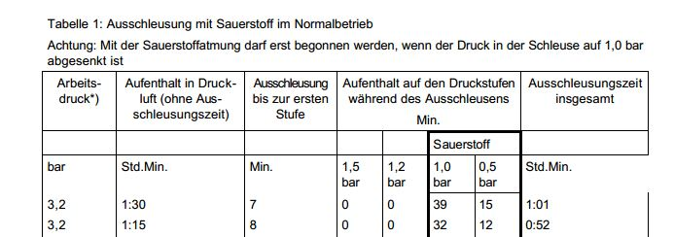

Experience-driven development

Peter Späth, founder as well as dive and hyperbaric superintendent of HydroWork GmbH & Compressed Air Work GmbH, which specialises in tunnel construction, can draw on both his own experience as well as that of the compressed air workers and lock attendants. To ensure safety during excess pressure work, but also to simplify the billing process with his customers, the professional diver and passionate technician has, over a period of two years, developed, designed, tested and protected by patent the mobile automation system in the PELI™ CASE.

The result is impressive and can be adapted to your TBM anywhere in the world within two hours. This is ensured by means of smart interfaces and friendly design for assembly and operation. Mr. Späth and his team offers special training sessions on site for firms that do not wish to rely on the HydroWork technical staff.

Times and shifts records can be archived with precision, reliability and online accessibility

The only thing that the compressed air worker requires for this type of documentation is a personalised ID Card. CAIS scans this in when the worker enters the manlock. This marks the exact recording of times. For example, it can be exactly logged when a worker has entered the manlock, whether the decompression time was observed and whether he was correspondingly correctly recovered again. A live transmission of data enables immediate analysis of the respective worker profile – even with Smartphone. As soon as the mobile automation system is in use, the customer or construction manager receives his access data on the our website www.compressed-air-work.net. Here he can log on anywhere and access the data. And he can do this anytime within the mandatory period of ten years.

INFO BOX III

CAIS Case

Characteristics:

The complete automation system is compactly stored in a PELI™ protective case made of 100% corrosion-free material. The case is water and dust tight, extremely resistant to breakage and temperature resistant from +60ºC to -23ºC.

Certifications and Approvals:

ATA Air Transportation Association Spec. 300: Drop Test
Penetration and stacking test, spray water resistant

US-Military Approval MIL-C-4150J

NATO NSN Approval and Tightness Test as per IP 67

Electric Source:

Operation with 230V alternating voltage, provided via non-heating connection. International use ensured by the plug connections Type B, Type C (Euro plug and shaped plugs)Type D, Type E+F and Type G.

In use from June 2014

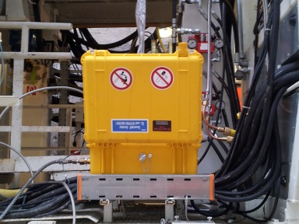
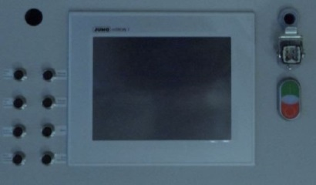
The advantages of the mobile automation system are evident, especially for the safety of workers. But it also means that the employer can fall back on precise figures in the event of a damages claim. Mr. Späth is even certain that "the need of proof will become increasingly important. And this is a difficult task without crystal clear data." In addition, the precise evaluation of assignments help the customer to calculate costs on present and future projects. Offers can be drawn up more precisely and personnel optimally deployed. And all this without making a big investment or expensive installations. This is because the system including the practical CAIS Case can be hired ( rented ) on a daily basis from Compressed Air Work GmbH. "It means in practice that the customer merely pays for one extra "worker per day". Once the project has been completed our team and case return home," explains Mr. Späth. However, what remains, is transparent and evident data, minimised risk and an easier comparison, for example for treatment and further treatment of compressed air sickness with compressed air doctors. You can therefore say: CAIS gives you peace of mind. The mobile automation system is fully available from June 2014.

At present we are speaking with Health and Safety authorities ( HSE ) worldwide to make CAIS – Compress Air Intervention System mandatory on the Tunneling industry when there is the need of Air Intervention Work on the TBMs.

Contact:

Francisco Hernandez Bianculli
International Business Development Manager

M +49 151 53039735
T +49 811 99885766
F +49 811 99885756
E francisco@compressed-air-work.net
W www.compressed-air-work.net
Munich – Germany
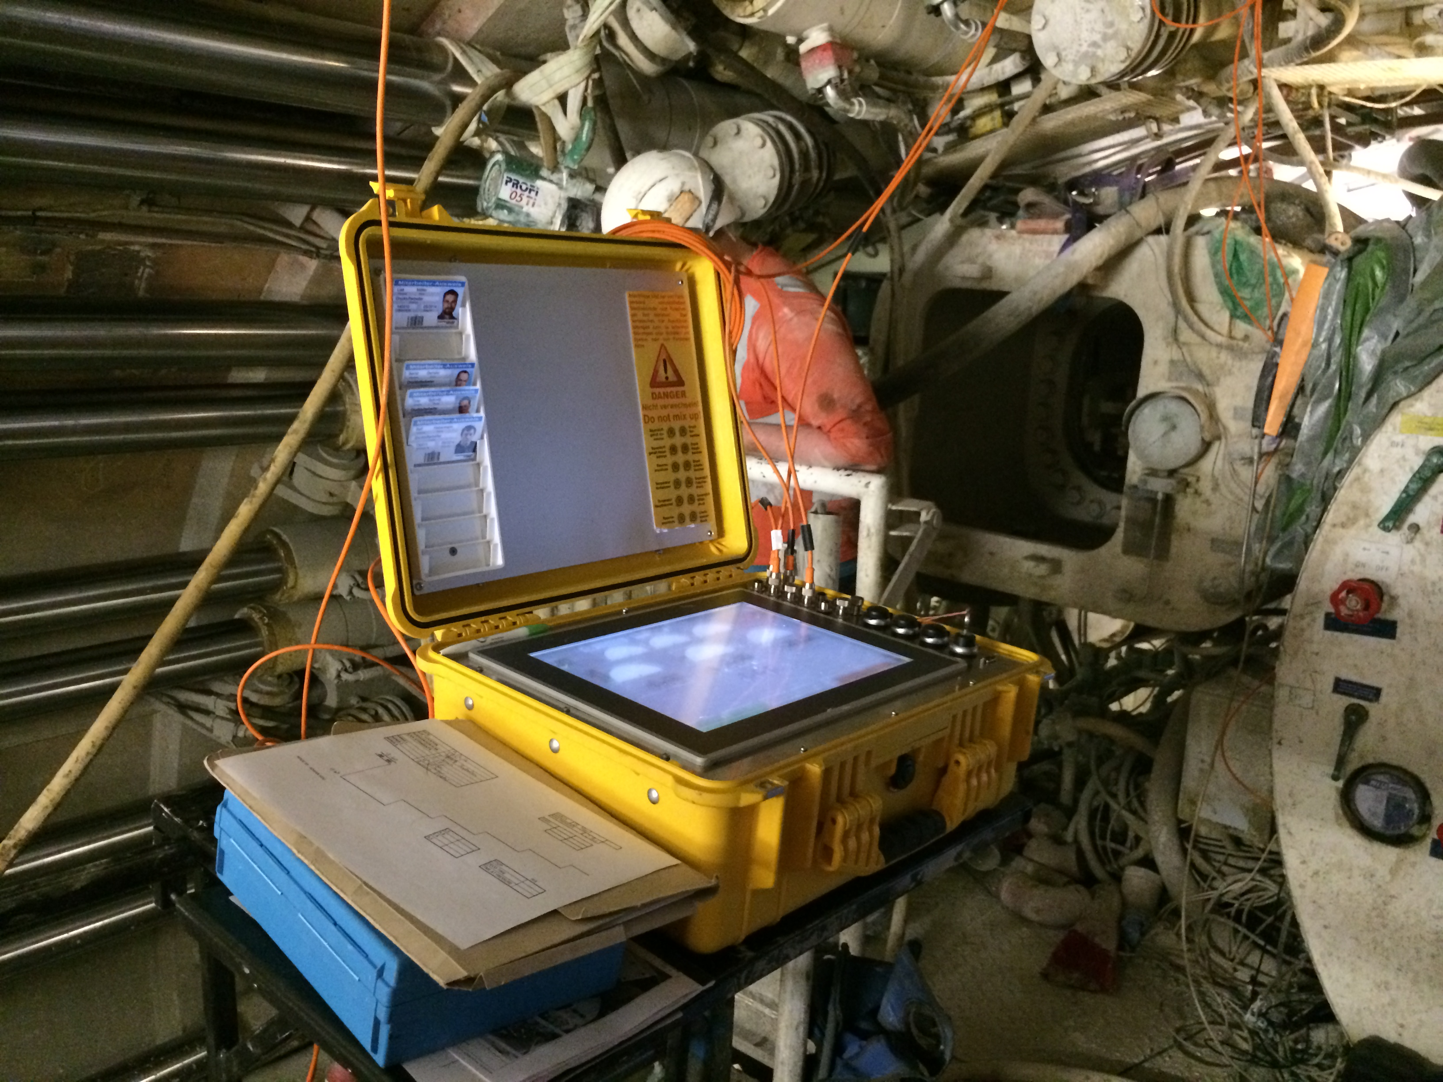
On youtube:
1.-) http://tiny.cc/9wzgpx
2.-) http://tiny.cc/bg9lpx

